Norfolk Vanguard
Oulton Parish Council’s submission at Deadline 7
Oulton Parish Council (OPC) welcomes the opportunity to respond at Deadline 7.
The Parish Council’s response consists of queries arising from updated written information received from the Applicant since Deadline 6, and issues raised at ISH 6 Environmental Matters on 24th April.
1. Cable Logistics Area: cable drum numbers
Applicant: ‘The Cable Logistics Area would have the capacity to store approximately 20 cable drums. The Applicant confirmed with Oulton Parish Council on 27 March 2019 that the construction methodology requires cable drums to be delivered directly to the cable joints. A number of cable drums may be stored at the cable logistics area to act as a buffer. However, the intention is for the majority of cable drums to be delivered directly to the joint locations. The total number of cable drums required for the entire onshore cable route is approximately 360 which is set out in Appendix 24.4 of ES Chapter 24 Traffic and Transport.’
OPC: The Cable Logistics Area has the ability to store up to 20 cable drums if needed. OPC still maintains that this has the potential to generate additional HGV movements as the need to store is an unknown quantity. The HGV numbers for the cable pulling phase for Link 68 can only relate to this work section, whereas stored cable drums are not necessarily for this section of the cable route, but may be needed elsewhere. If the need to store cables was only required occasionally, it is hard to understand the need for the acquisition of a specific area unless it was to be utilised regularly as a secure cable storage area for the whole project. OPC anticipates, therefore, that cable drums will go into the cable logistics area and out again to various parts of the cable route.
We have learned from our discussions with Orsted that their cable drums will arrive in ‘batches’ of 36 at the port, and be delivered as a batch to their Main Construction Compound in Oulton, for onward delivery to the cable route when needed. OPC seeks clarification as to whether Vattenfall anticipates its cable drums arriving at port in batches of, say, 20 - which may well need to be brought straight to Oulton, if sufficient work sections along the cable route are not yet ready?
OPC also assumes that the Cable Logistic Area will remain in situ for ‘Boreas’, which we believe will take up to 2 years for the cable pulling phase, as pre-ducting for that project would have been carried out during NV’s construction.
OPC seeks clarification as to whether the 360 cable drums required for the Norfolk Vanguard project would be repeated for the Boreas project, equating to a total of 720 cable drums to complete both phases?
2. Consented Hours
Applicant: The consented working hours are 7am to 7pm Monday to Friday (a single 12 hour shift), and 7am to 1pm on Saturdays, which is secured through Requirement 26. Outside of these hours, compounds (mobilisation areas) will effectively be locked and will not accept HGVs. To prevent HGVs arriving at a locked compound (outside of the consented hours) control of HGV deliveries is set out at Section 1.6.3 of the Outline Traffic Management Plan.
Requirement 26 then goes on to state…
Applicant: Requirement 26 does allow for some works to take place beyond the consented construction hours for essential continuous activities, such as concrete pouring or cable pulling. For example, once drilling has begun it may not be appropriate to stop the drilling process until the installation is complete due to drill head pressures and other technical requirements. Any works that are identified as potentially requiring out of hours working will require prior agreement with the relevant planning authority, which is secured through Requirement 26(3). Any application for out of hours working would need to set out potential traffic requirements and expected noise levels at the nearest residential properties and appropriate mitigation as required.
OPC: So it appears that, although the imperative to operate only within the consented hours is secured through Requirement 26, yet Requirement 26 simultaneously allows for work to be carried on outside of those hours. The Applicant highlights at least three significant construction operations where working outside of consented hours may be needed: pouring concrete, horizontal drilling and cable pulling. OPC seeks clarification regarding Requirement 26, as to exactly what working hours will apply for MA7. We are surprised and alarmed to see “cable pulling” included in the list of activities requiring continuous working - especially as cable pulling forms a very significant part of the latter half of NV’s construction phase - and almost the entirety of its sister project, Boreas. On behalf of our residents, we seek clarification therefore as to whether night-time (continuous) working is actually going to be a major feature of Vattenfall’s construction methodology.
It should also be noted that (as demonstrated at ISH 6) NCC Highways is still strongly requesting trenchless crossing for the B1149: would this involve working outside of consented hours, and additional HGV traffic?
If this is the case, then Oulton will experience night-time noise nuisance from both Orsted HOW3 operating night-time AIL deliveries to their Main Construction Compound and the potential for long periods of out-of-hours work on the cable route from Norfolk Vanguard’s operations. As the consented hours already allow for a very long (12-hour) working day, this would effectively grant permission for Vattenfall to work both night and day.
3. Link 68 traffic assessment
Applicant: Baseline traffic using Link 68 was estimated for the assessment submitted for Norfolk Vanguard. Automatic Traffic Count (ATC) data was subsequently collected by Hornsea Project Three along this Link 68. The Applicant has reviewed this dataset and can confirm that the numbers reported from the ATC survey do not significantly differ from the estimates used within the Applicant’s assessment.
OPC have commented at previous deadlines on our objections to the inadequacies of these baseline traffic figures, and Vattenfall’s dangerous reliance on already flawed data ‘borrowed’ from the Orsted project. Numbers of existing agricultural HGVs have been severely under-estimated by Orsted’s ATC, and Vattenfall are compounding the felony by failing to carry out their own independent assessments of baseline traffic, and are instead basing their projections on Orsted’s discredited data-set and their own estimated traffic data for Link 68.

4. Trenchless crossing of B1149

Applicant: ‘Where the onshore cable route crosses any roads using open cut trenching methods, traffic management would be employed. Where appropriate, single lane operation of roads would be utilised during installation with signal controls to allow movements to continue. Whilst the width of the B1149 is less than 7.2m kerb to kerb (required for single lane traffic management) the Applicant will introduce temporary widening at this location to ensure that single lane operation can be implemented during the road crossing.’

OPC: It is noted that the applicants have acknowledged that the B1149 is not wide enough to have single lane traffic control, but we are surprised to see they are now suggesting widening the road to be able to accommodate single-lane use. This would seem to be counterproductive since to widen the road would require additional land and road closures during its construction. Concerns by NCC about the potential for the road surface to fail because of trenching would be aggravated by the road widening process. We understand from ISH 6 that NCC is still wishing to pursue trenchless crossing. The B1149 will be a main route for both projects and, with current proposals for some alternative routes to avoid Cawston and utilise Heydon Road, then the B1149 will need to be operational at all times.

5. Link 75: Blickling Rd

Applicant: ‘Link 75 has been identified in the Outline Traffic Management Plan (OTMP) (DCO doc: 8.8) as requiring mobile traffic management (pilot vehicles). The OTMP highlights that “some localised carriage widening may be required”, i.e. the introduction of passing places where required to facilitate the proposed approach.’

OPC: It is noted that the Applicant’s approach to Link 75 seems to have developed from ‘pilot vehicles’ to road widening and passing places. There surely would be a need to know exactly where and how this will be achieved as the narrowest points along Link 75 are where there are:

1. Houses within a few metres of the road (sensitive receptors).
2. Banked road sections.
3. Verges where the road drops into a field culvert.
4. A narrow bridge with weight restrictions, requiring vehicles over 3 tonnes to keep to the centre of the bridge.
5. A listed building (Oulton Lodge), again at a narrow section of road.
6. No pavements or adequate verges.

There is a further listed building on Link 75 (Blickling Hall), owned by the National Trust, which is a magnet for thousands of tourists regionally, all the year round.

OPC challenges the possibility of the applicant being able to implement any meaningful “localised carriage widening” on the scale needed to actually improve matters. The whole length of the road would be involved, which would be unrealistic.

This sort of situation only serves to underline the point made by NCC Highways during ISH 6, namely that when traffic issues are left unresolved until after Examination or post-consent, then Highways are at a disadvantage in future negotiations with the developer.

OPC therefore urges the ExA to resolve these traffic issues in as much detail as possible within the DCO.

6. Noise & Vibration, and Air Quality assessments

The basis for the applicant’s air quality assessment was likely to be monitoring from local authorities at specific locations usually in urban areas or on major roads.
Norfolk Vanguard and Hornsea Three’s cable route and road links will be accessing rural areas. We therefore query whether the baseline data are relevant to locations like The Railway Gatehouse.
As an example, agriculture was responsible nationally for over 80% of ammonia emissions in 2017: has the applicant allowed for the existence in the immediate vicinity of The Gatehouse of a large intensive poultry farm and an outdoor and indoor pig rearing enterprise on the airfield? (See Appendix 1)
Furthermore, all agricultural vehicles run on diesel, with its dangerous emissions of PM 2.5. Has that fact been taken into account in the baseline data and added, along with the projects’ cumulative impact of HGVs, in terms of air quality emissions? (See Appendix 2)
In this regard OPC are fully aware of a submission made in the closing stages of the Examination process for Orsted, by a research fellow of the London School of Hygiene and Tropical Medicine, who is also a resident living on the B1149. Professor Barnett has become increasingly concerned about the lack of appropriate consideration being given to the public health effects of both these projects, especially in relation to particulate emissions from HGV traffic, which will affect residents throughout the county.
He has raised with Orsted’s Examination some very detailed questions relating to these effects, which OPC would like to submit to Vattenfall’s Examination for the Panel’s consideration at deadline 7.
Applicant: The Applicant has undertaken a cumulative impact assessment of the combined construction traffic from Norfolk Vanguard and Hornsea Project Three along Link 68, which was submitted to the examination at Deadline 5 (ExA; ISH1; 10.D5.3). This includes an assessment of noise, vibration and air quality impacts.
OPC: Noise, vibration and air quality assessments carried out for Link 68 and ‘The Old Railway Gatehouse’ appear to have been only desk-top surveys or data acquired from HOW3’s assessments. The residents of The Gatehouse are not aware of any physical monitoring assessments carried out by Vattenfall at or near their property.

The issue of air quality was raised at ISH 6. The baseline data which appears to have been used for air quality is sourced from the local authorities and all of their data is urban-based, according to where monitoring equipment has been placed, usually on city roads or main A roads; there are no monitoring sites on rural roads. (See Appendix 3)

Appendix 1

‘There was an increase of 0.7 per cent in emissions of ammonia between 2016 and 2017. Increases since 2013 go against the trend of steady overall reduction observed from 1998 to 2013. Agriculture accounted for 87 per cent of emissions from ammonia in 2017.’

Data from DEFA National Statistics Release: Emissions of Air Pollutants in the UK 1970 - 2017
Ammonia
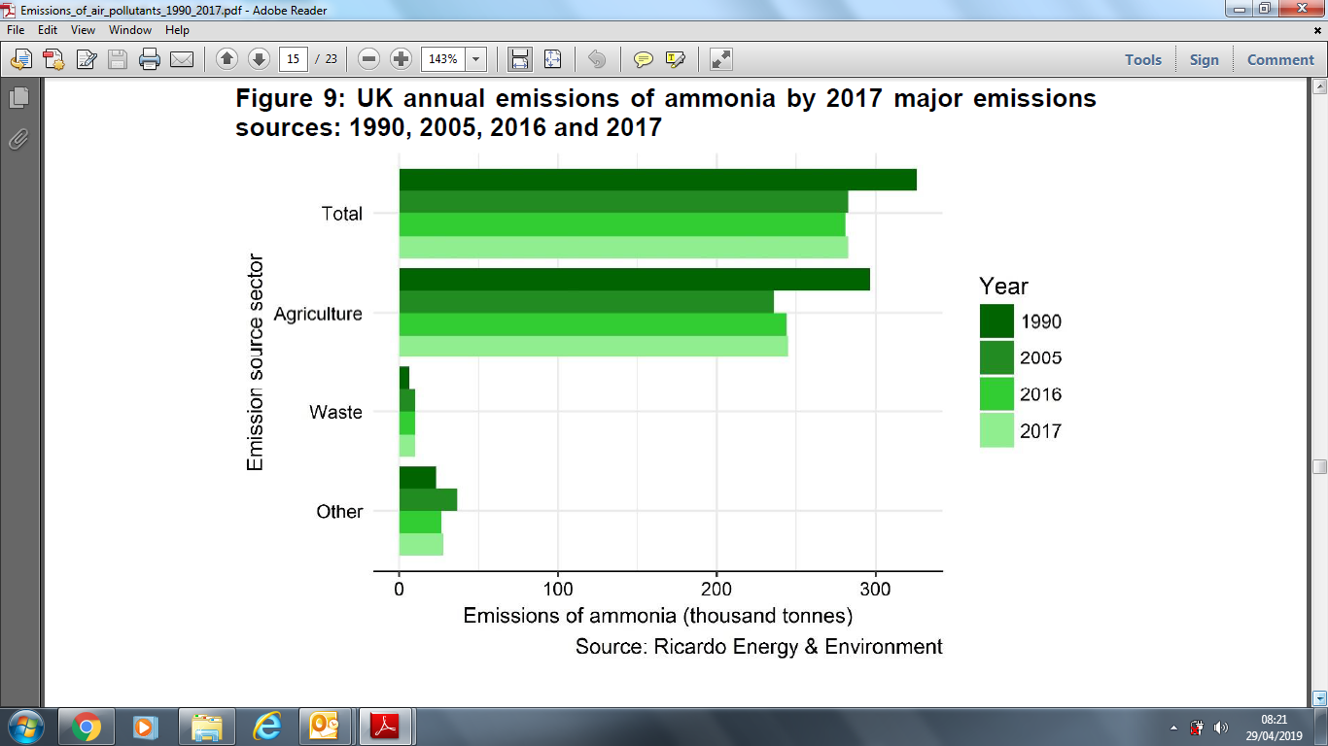

Appendix 2.

Data from DEFA National Statistics Release: Emissions of Air Pollutants in the UK 1970 - 2017

PM10

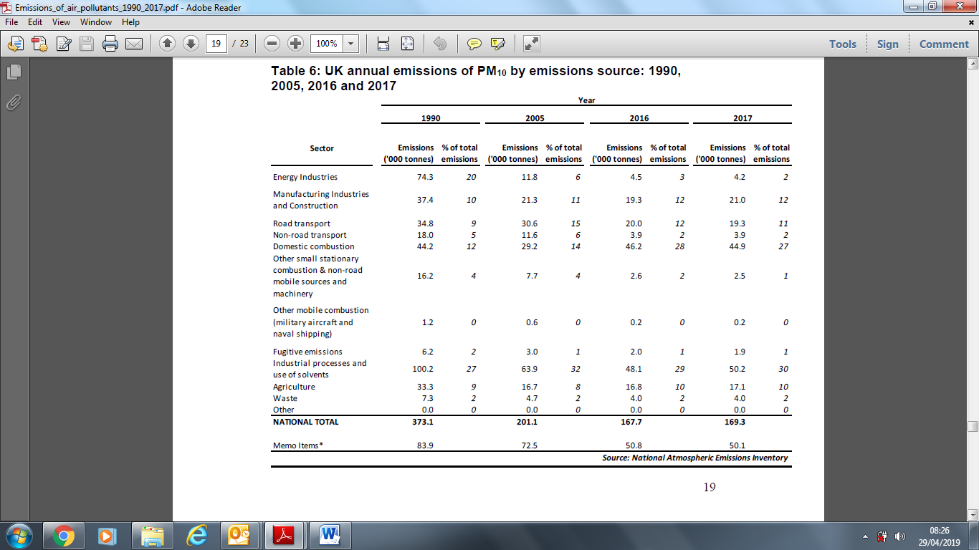

PM2.5
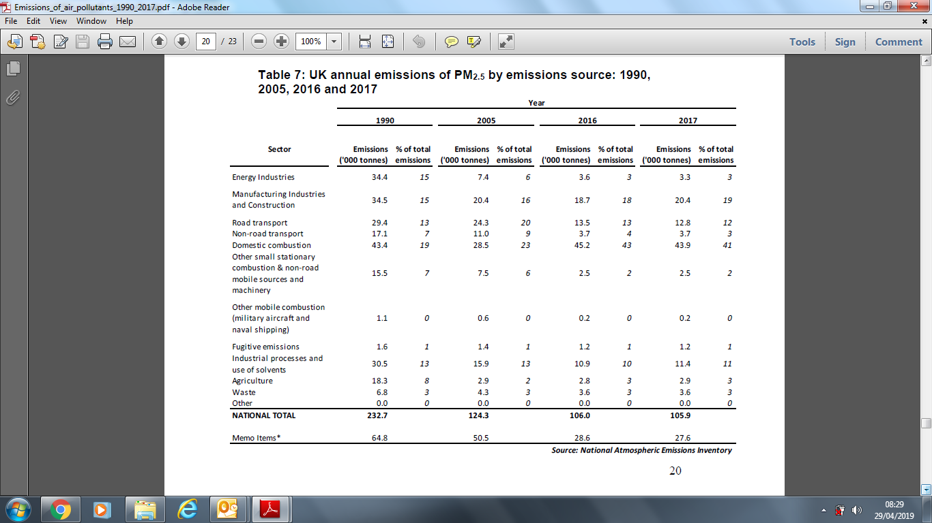

Appendix 3.

The map below (Taken from Air Quality Annual Status Report 2018 – Broadland District Council) shows the monitoring locations grouped around Norwich. No rural monitoring identified.

